Teacher Resources: littleBits

Table of Contents
Table of Contents 1
STEMbound Contact Information 2
Equipment Checklist 3
Recommended Set Up Instructions 4
FAQ 4
Extension Resources 4

STEMbound Contact Information
If anything seems missing or damaged, please contact us as soon as possible. Thank you!

Contact | Contact Information
STEMbound Team | Email: STEMbound@sourcewell-mn.gov

Website Quick Links
STEMbound Home Page | Equipment Check-out Library  Equipment Request | Consultant-led Learning  Consultant-led Request
STEM Network | Partnership in Planning Request | Professional Learning

You can access the above links and more at: https://mn.sourcewell.org/education/STEMbound

Equipment Checklist

Item | Picture | Quantity
STEAM Classroom set | 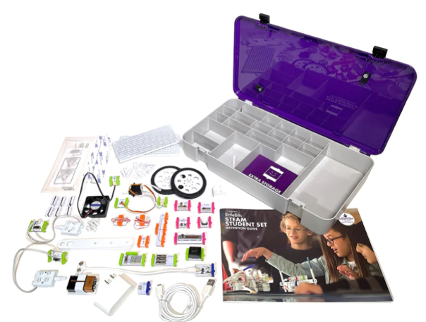 | 1 kit
Make: Getting Started with littleBits | 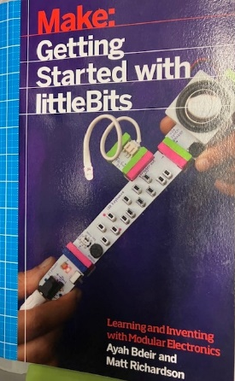 | 1 book
Student Invention Guide | 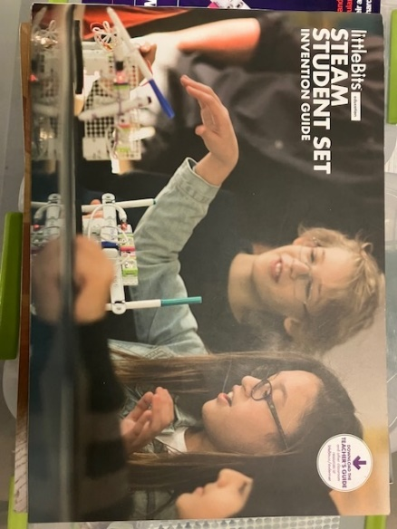 | 15 books

Recommended Set Up Instructions
These kits can be used 1:1, 2:1, or with small groups. When introducing kits, take some time to go through and explain/explore what each piece does. These are VERY fragile. To ensure the kits can be a continued resource for you in the coming years, please instruct students to handle with care. If something does break, please set it aside with a note as to which kit it belongs so we can update the kit for the next school.

The kits come with student activity books to help get you started. Another resource for you is the Little Bits Classroom where you will find several classroom activities. Classroom.littlebits.com

FAQ
What are littleBits? Little Bits was the company that invented the electronic building block. Little Bits made modular electronics kits for kids, which snap together with small magnets for prototyping and learning.

How do littleBits work? Sphero littleBits are modular electronic bits which snap together with small magnets to teach kids the basics of electronics. All littleBits products are designed for in-home or classroom use, making these circuits kits a wonderful educational STEM tool for kids 8+!

How do you use littleBits? Build a circuit to bring an invention to life. To learn how to create more advanced projects with littleBits or for more hands-on, guided activities, you can explore littleBits by visiting classroom.littlebits.com/explore/search.

Extension Resources
- Test circuits using the Fuse app online at https://fuse.littlebits.com/builder
- Explore the Quick Start Guide at https://bit.ly/2Q551Lp
- Explore the STEAM Student’s Teacher’s Guide at https://bit.ly/3mw2ENU
- Explore the Educator’s Guide at https://bit.ly/3t1sFqB
- Want some help connecting to your class content? Contact us about our Partnership in Planning option for help with planning, executing, and/or assessing.

